PURCHASE SPECIFICATIONS FOR A SOLAR HELIPAD LIGHTING KIT

MODEL: SP-401 SOLAR HELIPAD LIGHTING KIT

1.0 General Overview

Solar Helipad Lighting Kit shall allow to permanently illuminate helipad or heliport.

The Kit shall offer the following features:

- Shall use solar energy as the main power source,
- Shall operate continuously without the risk of blackout,
- Shall offer remote activation and control of helipad lights,
- Shall be compatible with Night Vision Goggles (NVG).

2.0 Description

Solar Helipad Lighting Kit shall consist of:

Standard kit includes: | Quantity
SP-401S Solar Helipad FATO Light | 16
SP-401S Solar Helipad Approach Light | 9
UR-201 Control & monitoring Unit | 1
Optionally kit can include: | Quantity
SP-401S Solar Helipad TLOF Light | as per customer’s requirements
SP-401S Solar Helipad Taxiway Light | as per customer’s requirements
UR-101 Handheld Controller | 1
OCT-401 Charging Station | 3
Rubber mounting pad (fits all types of surface) | 25

3.0 Proposed Design of Solar Helipad Lighting System

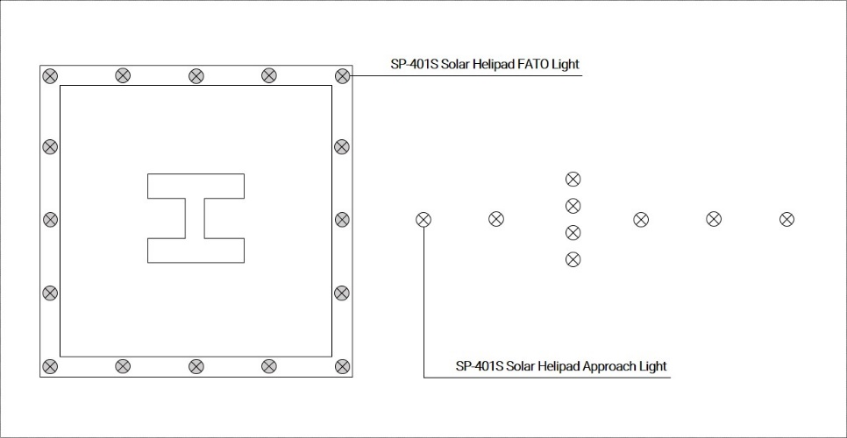

4.0 Solar Power Supply

- Helipad lighting shall be powered by solar energy,
- Solar energy power generation shall be performed by solar panels,
- Each lighting unit shall use solar panel installed separately from light unit body,
- Entire solar panel shall face one geographical direction for optimal energy collection,
- Solar panel shall be mounted at circa 33 degrees tilt,
- Entire solar panel shall have minimum nominal power output of 20 Watts.

5.0 Energy Storage

- Helipad lighting shall use batteries as the main power source,
- All models of the helipad light shall be equipped with nominal 12 volt battery systems,
- The capacity of the batteries shall provide autonomy of helipad lighting for at least 170 hours at the minimum intensity level,
- The lights shall be equipped with two batteries, each battery shall have minimum power capacity of 108 Wh,
- Total capacity of batteries shall not be less than 216 Wh,
- The batteries shall be valve-regulated lead-acid (VRLA) or Cyclon type or Li-On type,
- Failure of one of two batteries shall not stop light from operating – hence the light should be able to operate (on / off) only using one battery,
- The batteries shall be replaceable. Replacement should require no special tools and shall take no longer than 15 minutes per light,
- Manufacturers offering lights energized by self-designed battery-packs shall offer standard and available worldwide battery,
- The battery operating temperature range published by the manufacturer shall be at least from -40 to +80 °C,
- The light’s operation and depth of battery cycling while in autonomous mode shall be designed for not less than 1.200 cycles battery life.

6.0 Remote Control

- Helipad Lighting shall offer wireless remote activation and control
- Wireless communication shall use mesh-protocol (manufacturers using point-to-multipoint radio protocol shall offer mesh protocol),
- There shall be no limit to the number of lights the controller can communicate with provided they are within the required radio range,
- The wireless system shall communicate using non-licensed 868 MHz radio frequency with power output of no more than 20 mW,
- Frequency band should require no special separate approval or be designated for other types of communication (like GSM carriers: 900 / 1800 Mhz),
- The system shall be capable of normal operation in the presence of RF activity typical for a helipad environment.

7.0 Solar Helipad Light Specifications

Each light shall consist of or be capable of:

- LED optics,
- LEDs must have a lifespan of at least 100.000 hours,
- The optical LED head shall be replaceable. The manufacturer shall offer complete optics replacement kits including required tools to perform the replacement,
- The light’s dome shall be glass,
- The dome shall be replaceable on site in case of damage,
- Non-corrosive polycarbonate casing,
- Built-in microcomputer with integrated radio-transceiver,
- Externally mounted (replaceable) and tilted solar panel for optimal energy collection,
- Two power ports allowing to energize the light simultaneously:
  - via solar panel and,
  - electrical grid,
- Two independent built-in batteries,
- External (replaceable) antenna for wireless control & monitoring,
- Emergency On/Off button,
- Built-in battery status indicator,
- Waterproof pressure stabilizing valve,
- Body of the light shall have Ingress Protection rating of minimum IP67. Compliance shall be confirmed by test report issued by third party laboratory or institute,
- The light (fully assembled) shall be tested against jet blast and wind load of minimum speed of 480 kph. Compliance report shall be provided,
- Light shall have Impact Rating of not less than IK10. Compliance shall be confirmed by test report issued by third party laboratory or institute.

The entire light shall be delivered complete and ready to install. It shall not require assembly except for solar panel, antenna and mounting accessories.

8.0 Control & Monitoring Unit Specifications

Remote control of Solar Helipad Lighting shall be provided by Control & Monitoring Unit (CMU).

The CMU shall allow for 3-way remote control over helipad lighting:
- By using knobs located on the CMU front panel,
- Via VHF (Air-Band Radio): frequency range 118-136 MHz,
- Via GSM (voice call or SMS),
- In case of Wireless signal failure the light shall allow for manual activation using Emergency On/Off Button,
- Automatic Alarm SMS: in case of light’s critical failure (e.g. lack of wireless control over the light or low battery) – user will automatically receive alarming SMS informing about critical failure.

9.0 Quality Assurance

Excluding the batteries, the system, including solar panels, LEDs, optics, electronics, mechanicals and associated components, shall be guaranteed for a minimum of two years. The batteries shall be guaranteed for 1 year.

The lighting equipment included in the Solar Helipad Lighting Kit shall be manufactured by ISO 9001:2008 certified manufacturing facility.

10.0 Ordering code
Edit the ordering code if needed.
Default setting:

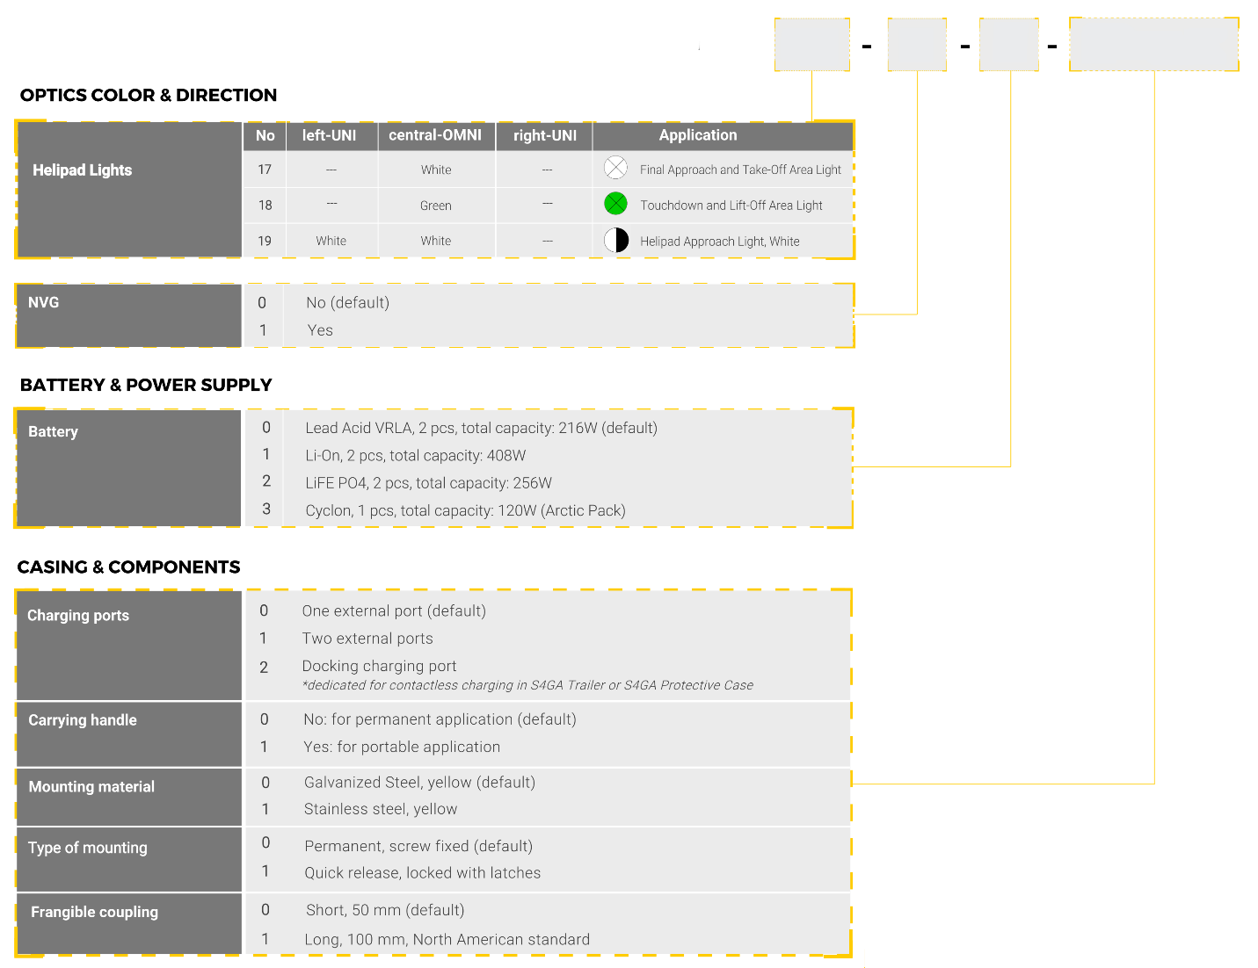
0
17
00000
0

