PURCHASE SPECIFICATIONS FOR A PORTABLE RUNWAY THRESHOLD LIGHT
MODEL: SP-401P PORTABLE RUNWAY THRESHOLD LIGHT

General Overview

Each light shall consist of or be capable of:

- LED optics,
- Non-corrosive polycarbonate casing,
- Built-in microcomputer with integrated radio-transceiver,
- Two power ports allowing to energize the light simultaneously:
  - via solar panel and,
  - electrical grid,
- Two independent built-in batteries,
- External (replaceable) antenna for wireless control & monitoring,
- Wireless network should be based on mesh (not point-to-multipoint) protocol and using non-licensed frequency band such as 868 Mhz,
- Each Light should be equipped with emergency On/Off button.

The entire light shall be delivered complete and ready to install.

1.0 Physical and Mechanical Parameters

- All batteries and electronics shall be contained within the light,
- Maximum height of the portable light (excl. antenna) shall not be more than 360 mm,
- Maximum weight of the portable light shall not be more than 15 kilograms,
- The body of the light shall be polycarbonate,
- The light’s dome shall be glass,
- The light should be equipped with waterproof pressure stabilizing valve,
- Body of the light shall have Ingress Protection rating of min. IP67. Compliance shall be confirmed by test report issued by third party laboratory or institute,
- Light shall have Impact Rating of not less than IK10. Compliance shall be confirmed by test report issued by third party laboratory or institute,
- Lights dome shall be replaceable on site in case of damage,
- The optical LED head shall be replaceable. The manufacturer shall offer complete optics replacement kits including required tools to perform the replacement,
- The batteries shall be replaceable. Replacement should require no special tools and shall take no longer than 15 minutes per light,
- The batteries shall be of standard type available from the local battery stores (worldwide battery standard),
- All type of lights (including runway, taxiway and obstruction) shall be equipped with the same type of battery.

1.1 Mounting of the lighting unit
- The light shall be capable for mounting at all types of surface including grass and concrete,
- The mounting shall include frangible coupling.

1.2 Light Capabilities

- The light shall be capable of at least 99 x different brilliancy levels,
- The light shall be capable of operation during the day if required,
- The light shall be equipped with manual on/off button to allow for light activation when it is operated without wireless control,
- The lights shall be equipped with led indicator showing: [1] battery level and also [2] charging status.

By switching manual on/off button on any light installed on the airfield the rest of lights located within radio range shall be remotely activated in less than 1 sec.

2.0 Operational Parameters

2.1 Optical Performance

LEDs must have a lifespan of at least 100.000 hours.

The light shall provide optical performance meeting or exceeding the following specifications:

Application | Intensity
Runway Threshold Light | The average light intensity of Green at the highest level must not be less than 400 Candela (cd) (tested and certified by 3-rd Party laboratory)

Light intensity and color shall have third-party testing and certification from Intertek or Bureau Veritas or STAC or TUV Rheinland or CAA.

Optionally optics can be additionally equipped with Infra-Red LEDs to enable covert operations using NVG -goggles.

2.2 Solar Power Option

- The lighting unit shall be capable to be converted to solar-powered runway threshold light by connecting to a solar panel installed separately from light unit body.

2.3 Energy Storage

- All models of the light shall be equipped with nominal 12 volt battery systems,
- The lights shall be equipped with two batteries, each battery shall have minimum power capacity of 108 Wh. Total capacity of batteries shall not be less than 216 Wh,
- Failure of one of two batteries shall not stop light form operating – hence the light should be able to operate (on / off) only on one battery,
- The batteries shall be valve-regulated lead-acid (VRLA) or Cyclon type or Li-On type,
- The batteries shall be replaceable,
- Manufacturers offering lights energized by self-designed battery-packs shall offer standard and available worldwide battery,
- Light unit shall be equipped with built-in battery status indicator,
- The battery operating temperature range published by the manufacturer shall be at least from -40 to +80 °C,
- The light’s operation and depth of battery cycling while in autonomous mode shall be designed for not less than 1.200 cycles battery life,
- The light shall be able to operate continuously at the minimum intensity level for not less than 230 hours.

2.4 Power

The light shall be capable of drawing power from its internal lead-acid battery.
The battery shall be capable to be charged by four alternative methods:
- via back-up charging station,
- via solar panel,
- via electrical cable (24VDC),
- via drop-in charging port.
When connected to external electric grid (24VDC) and in case of battery failure lighting unit shall still be able to continue operation.

2.5 Electronics

The light’s control system shall have:

- Temperature-compensated Maximum Power Tracking battery charging,
- Low-voltage cut-off to prevent over-discharge of the battery system,
- Temperature sensor.

The light and controller shall be capable of receiving firmware upgrades.

3.0 Wireless Specifications

- Light shall be wirelessly controlled,
- Wireless communication should use mesh-protocol (manufacturers using point-to-multipoint radio protocol shall offer mesh protocol).

3.1 Wireless Signal

- The light’s antenna shall be detachable / replaceable,
- The light should be equipped with external antenna to maximize radio range,
- There shall be no limit to the number of lights the controller can communicate with provided they are within the required radio range,
- The wireless system shall communicate using non-licensed 868 MHz radio frequency with power output of no more than 20 mW,
- Frequency band should require no special separate approval or be designated for other types of communication (like GSM carriers: 900 / 1800 Mhz),
- The system shall be capable of normal operation in the presence of RF activity typical for an airport environment.

4.0 Quality Assurance

Excluding the batteries, the system, including LEDs, optics, electronics, mechanicals and associated components, shall be guaranteed for a minimum of two years. The batteries shall be guaranteed for 1 year.

The light shall be manufactured by ISO 9001:2008 certified manufacturing facility.

5.0 Turn-Key Operation

The light shall be ready for installation upon delivery. Assembly consists only of threading the antenna onto the light, activating the light through a single button-press on the light, and attaching to the mounting accessories and solar panel (if applicable).

6.0 Ordering code
Edit the ordering code if needed.
Default setting:

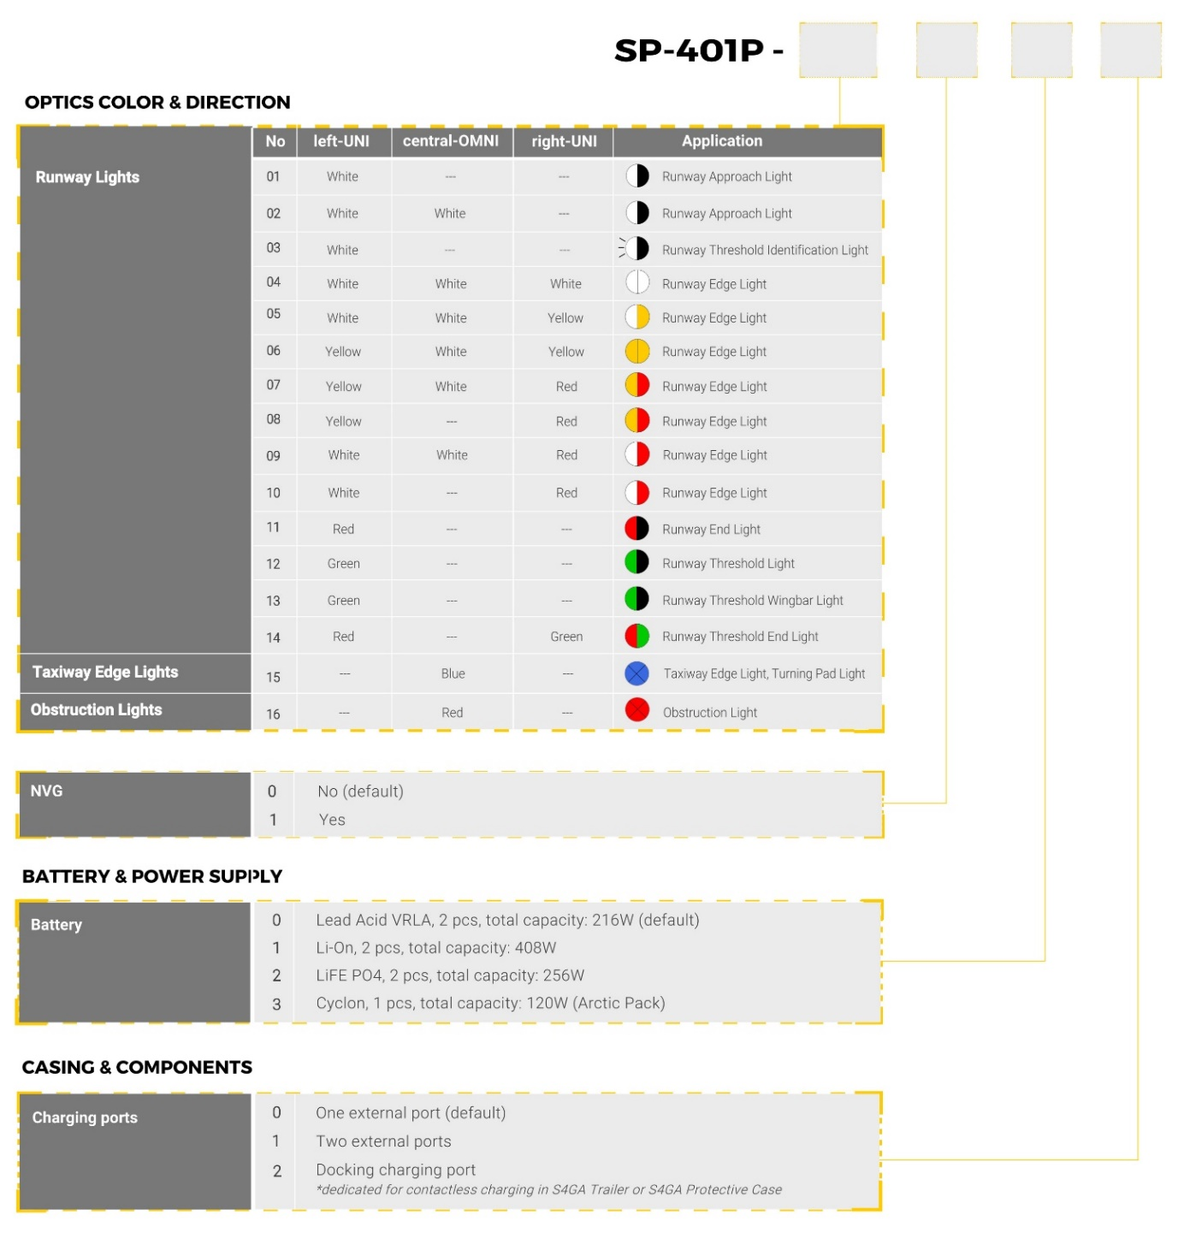
0
0
0
12

